GENERIC

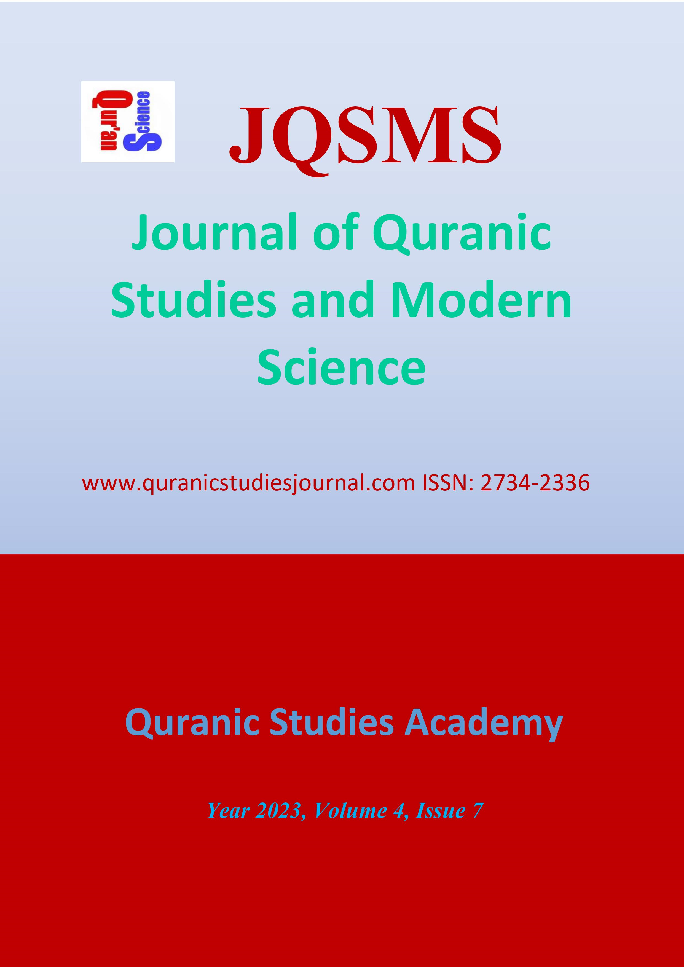
Editors
Sadiq Safiyanu
email: jqsms.submissions@gmail.com

Editorial Board
Prof.Dr. Suat Yıldırım, Turkey
Prof.Dr. Muhittin Akgül, Netherlands
Prof.Dr. M. Lütfi Bozdoğan, Turkey
Prof.Dr. Abdullah Demir, Nile University of Nigeria
Prof.Dr. İsmail Albayrak, Australian Catholic University, Australia
Prof.Dr. Şenol Dane, Nile University of Nigeria
Prof.Dr. Ahmet Bedir, USA
Prof.Dr.Osman Köroğlu Nile University, Nigeria
Prof.Dr. Ferah Armutcu, Istanbul University, Turkey
Asst.Prof. Muhammed Musa Abdujabbarov
Prof.Dr.Ahmet Arabacı Nile University, Nigeria
Dr. Bilal Çelik, Nile University, Nigeria
Prof. Dr. Rifat ŠKRİJELJ, University of Sarajevo, Bosnia Herzegovina
Prof.Dr. Keneş USENOV, Jalal-Abad University, Kyrgyzstan
Prof. Dr. Bürküt DARBANOV, Jalal-Abad State University, Kyrgyzstan
Prof. Dr. İrfan MORİNA, University of Pristina, Kosova
Prof.Dr. Abdilbaet MAMASIDIKOV, Kyrgyzstan Economy and Entrepreneurship University, Kyrgyzstan
Prof. Dr. Osman Köroğlu, Nile University, Nigeria
Prof. Dr. Tologon OMOSHEV, Kyrgyzstan Economy and Entrepreneurship University, Kyrgyzstan
Assoc.Prof.Dr.Gülcamal RISKULOVA, Jalal-Abad State University, Kyrgyzstan
Assoc.Prof.Dr. Erlan BAKIEV, American University of Central Asia, Kyrgyzstan
Dr. Oktay GULİYEV, Azerbaijan State Economy University, Azerbaijan
Dr. Gülmira SATIBALDİEVA, Jalal-Abad State University, Kyrgyzstan
Dr. Gülbarçın OROZBAEVA, Jalal-Abad State University, Kyrgyzstan
Dr. Bruno SURDEL, Centre for International Relations, Warsaw - Poland
Dr. Murat Akyüz, Nile University, Nigeria
Dr. D. Rajan, University of Africa, Nigeria

Address
Haznedar Mah. Altıntaş Sk. No: 8/10 Güngören/İstanbul/TÜRKİYE
http://www.quranicstudiesjournal.com

Puplisher

Prof. Dr. Abdullah Demir

Volume 4 Issue 7 2023
Jenerik
Human Rights in Islamic Law
Prof. Dr. Abdullah Demir
“Yaratıcı İnsan” Söyleminin Teolojik Kritiği
Ahmet YILMAZ, Ph.D
An Evaluation on the Torah, the Bible, and the Quran
Ahmet Zeki
The Necessity of Interpreting the Qur'an According to Scientific Developments
Prof. Dr. Abdullah Demir

Indexing

ResearchGate

Digital Object Identifier System (doi.org)

